Using TIS Self-Service
Homepage
This is the landing page of TIS Self Service. 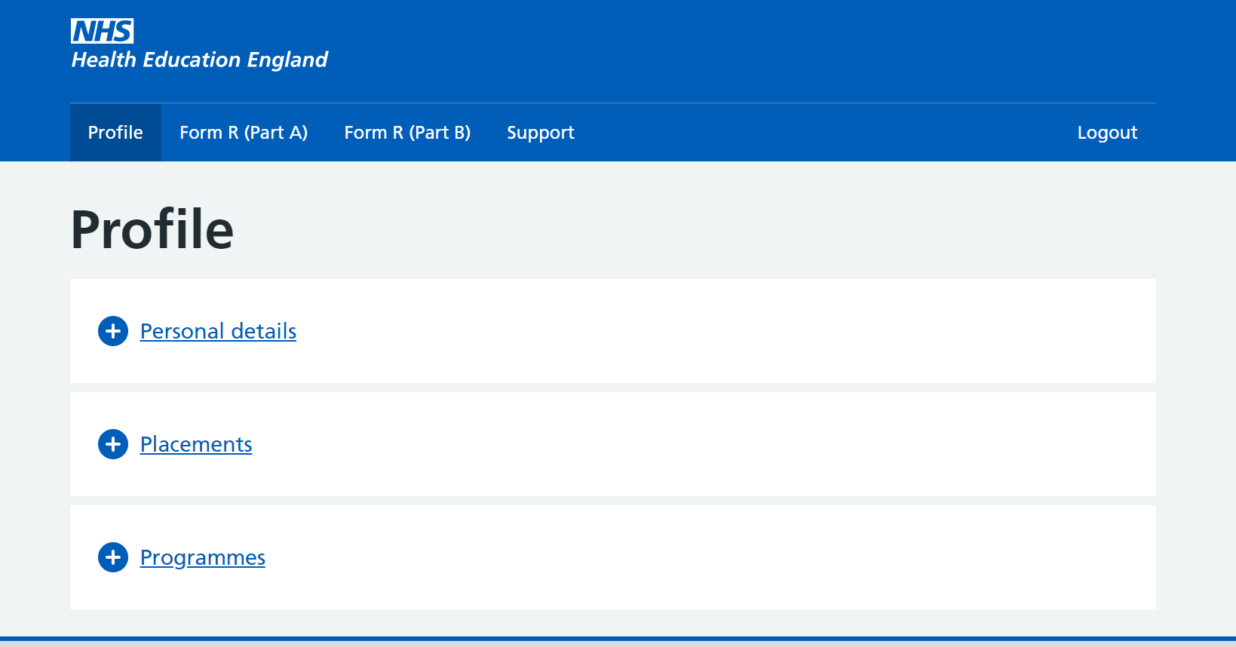
There are multiple navigational tabs on the top crossbar:
1. Profile – contains your trainee data held in TIS
2. Form R (Part A) – enables you to complete your Form R (Part A) and view previous submissions
3. Form R (Part B) – enables you to complete your Form R (Part B) and view previous submissions
4. Support – enables you to contact your local office / another local office
Profile
Contains trainee details.
Click on the plus button to reveal more.
If any of your details require amending, please contact your local office via the support tab.
Personal Details
Contains your personal details:
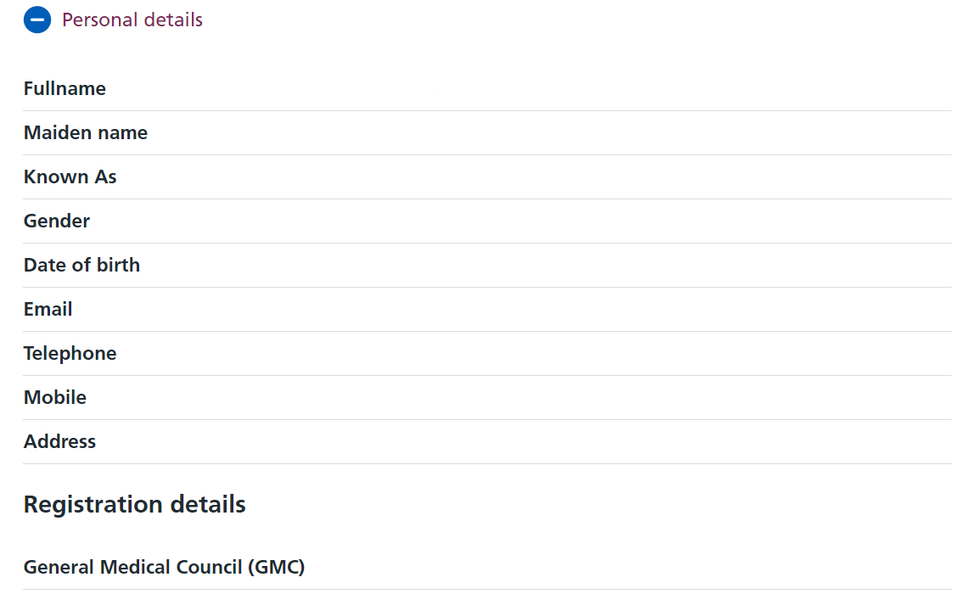
Placements
Shows a list of your placements in chronological order.
Some examples of how placement data will appear:
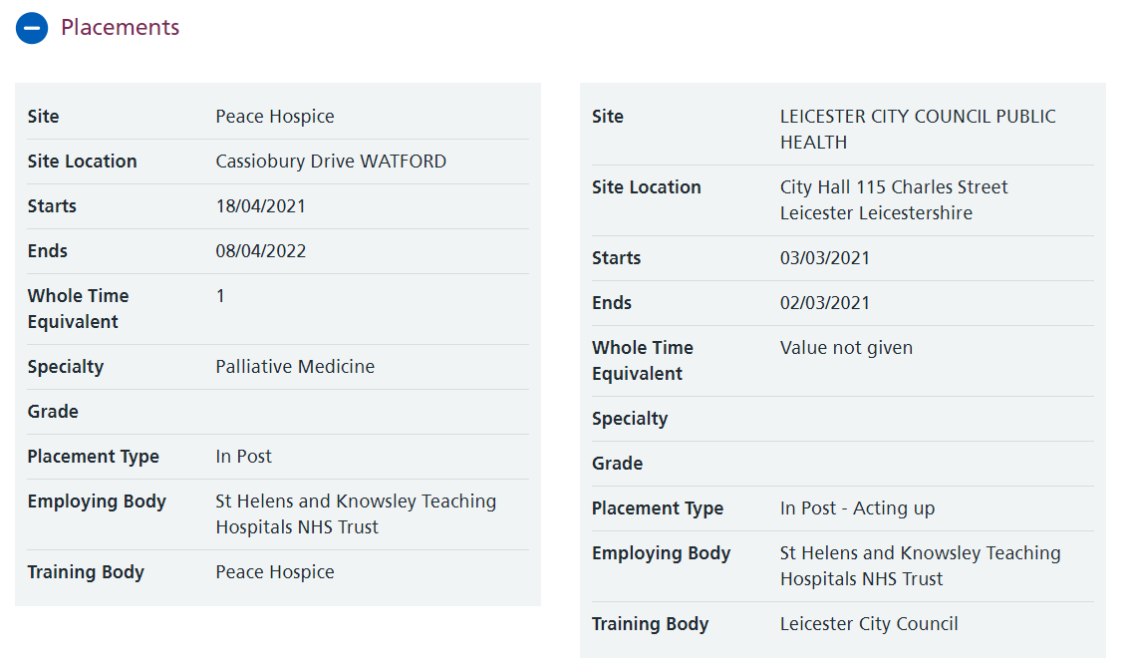
Programmes
Shows a list of all programmes and any curricula that you are attached to.
The start and end date for each curriculum and the overall programme are displayed.
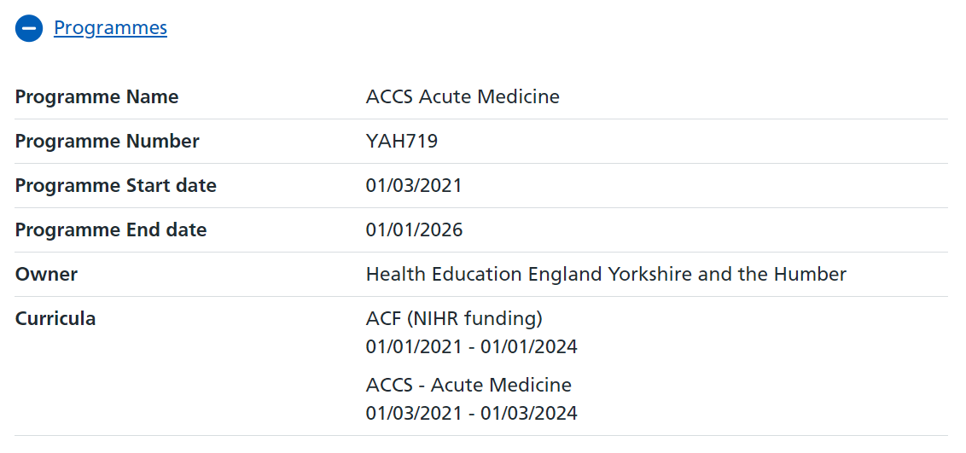

Form R (Part A)
Allows you to submit a new Form R (Part A) and view previous submissions.
Click 'Submit new form' to begin a new form.
Click 'Form submitted on…' and the particulate date of the previously submitted form that you want to access.
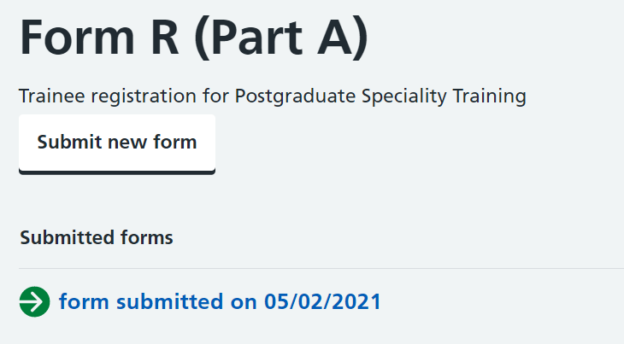
The form does not have to be completed in one sitting as you can 'Save & Exit' midway.
These buttons will appear at the bottom of the page.
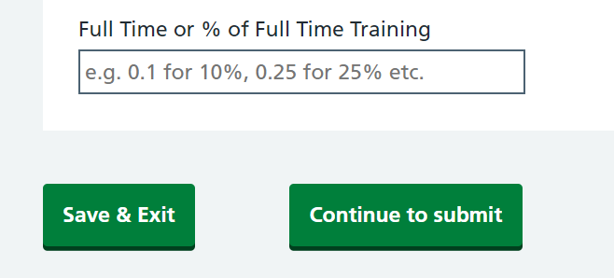
Saving and exiting will enable you to continue from your draft form later by selecting 'Edit saved form'.
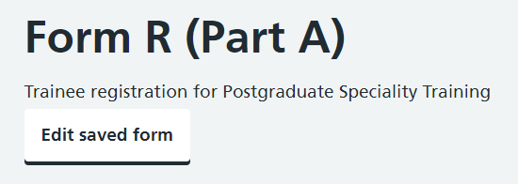
One point to note is that the form has inbuilt validation which may prevent you from saving / continuing to the next section if the page is incorrectly completed.
If this is the case, a red text box will appear asking you to 'Please check highlighted fields'.
Training Grade is a mandatory field therefore a grade must be selected.
The Training % must be a value between 0 to 1 (inclusive). 12 is clearly greater than this, so an error message is generated to prompt you to fix it.
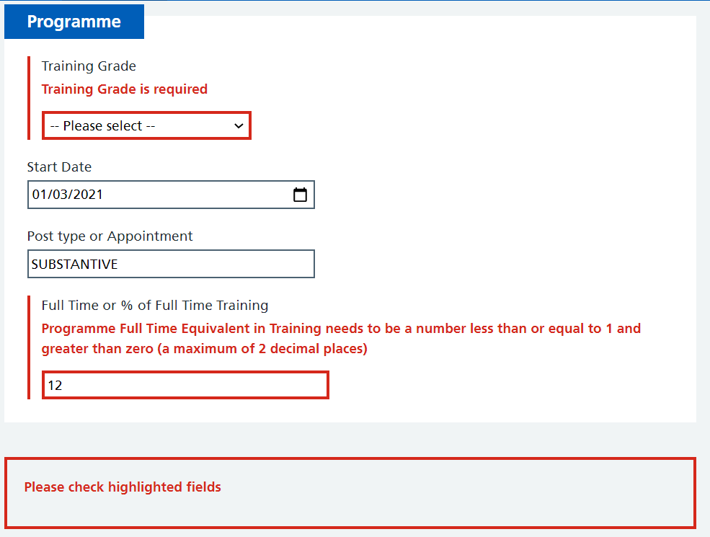
Once these errors are corrected, will you be able to save and progress in the form.
One of the questions asks for a revalidation date. You should be able to check your revalidation submission date by logging into your GMC connect account. If you have any trouble accessing this then please contact the GMC.
Once submitted, please save a pdf copy of your form by following the instructions in the highlighted hyperlink and upload the PDF document to your compliance passport as detailed in the link below
https://support.fourteenfish.com/hc/en-gb/articles/360016671257-Uploading-Form-R
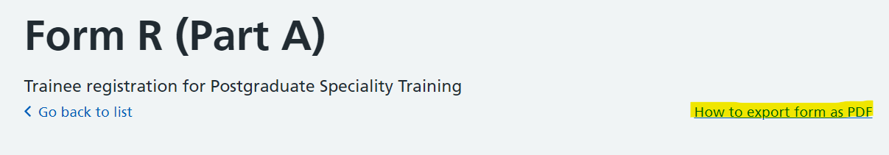

Form R (Part B)
Allows you to submit a new Form R (Part B) and view previous submissions.
This is the same process as the Form R (Part A).
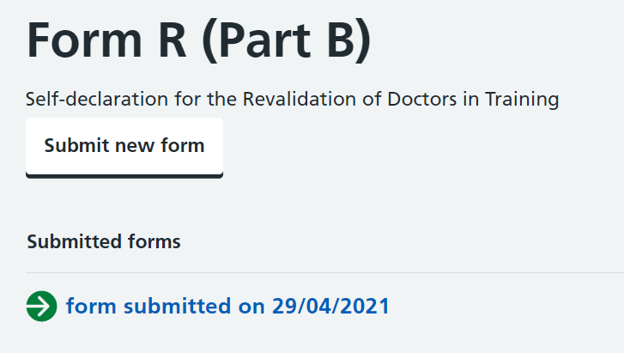

Support
Allows you to contact your local office.
The contact is defaulted to the local office that manages your current programme.
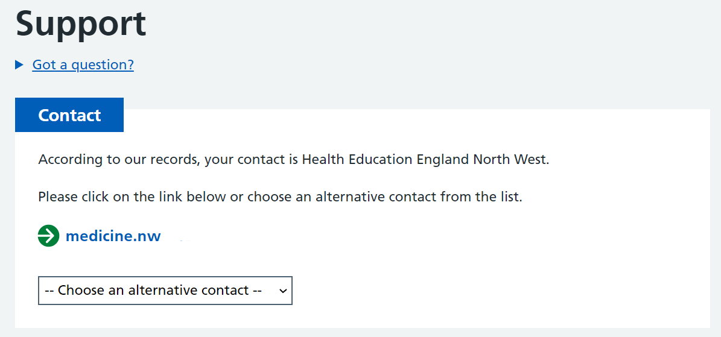
However, there is an option to select another Local Office by clicking on the dropdown menu
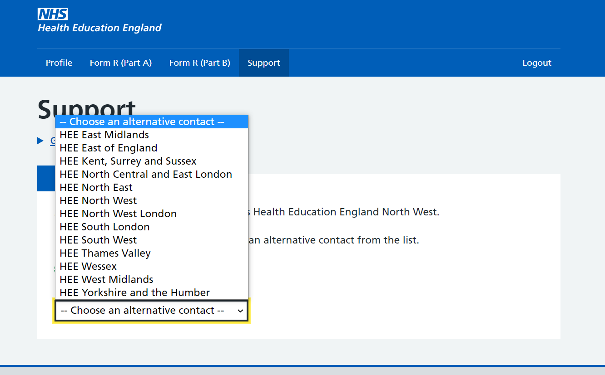
Clicking on the email address will open your email client and have the selected Local Office's contact details prepopulated.

Feedback

How to Leave Feedback
Please leave feedback using the inbuilt Hotjar tool.
Clicking on the arrow at the bottom of the page will open a survey to complete that will help us improve Self-Service.
If the arrow is not appearing, please clear your cache and cookies.
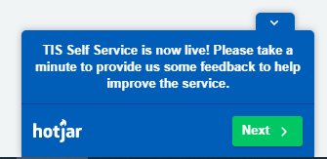
If you want to provide further feedback and include screenshots then please email: HEE.TIS@hee.nhs.uk

