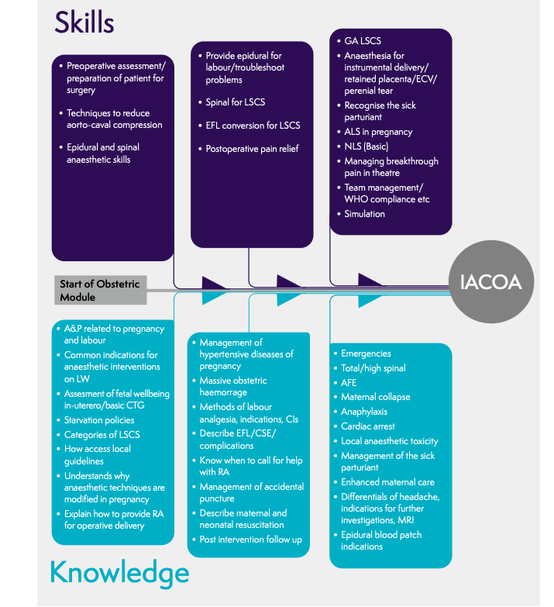

Discussion Topics

Epidurals - troubleshooting, technique, top ups

PDPH - management, options, adjusting epidural doses, intrathecal catheters, when to worry

General anaesthesia - drugs, steps, preparation, failed intubation

Spinals - doses, alternative - placenta, 3rd degree tear, breakthrough pain

PET - anaesthetic considerations, practical management e.g bloods pre regional, fluid management

Major obstetric haemorrhage - predicting, preparing, call for help, practical aspects of uterotonics e.g anti emetic, timing of haemobate

Critical incidents - arrest, LAST, anaphylaxis

Facilitating Guide

E.g Epidurals

Start with facilitator - maybe describing their first epidural/attempts at epidurals

Who has done an epidural?

What technique did you use? What have you seen done?

How are the epidurals managed locally? - pumps/ top up

What sort of things would make you think twice before siting an epidural?
- bloods, last ve, medical problems, clexane, CTG concerns, Multips

Has anyone had a poorly working epidural?
How could you manage that - positioning, bupivacaine, pulling epidural back
What would make you think it need re-siting?

Top ups - Anyone done any? What do people think of them? What do people use? How long does it take to get a good block ?

Having the confidence to refuse/abandon/call for back up

Does anyone have any questions about epidurals?

Does anyone have a case they want to discuss now?

Would anyone like to present a case at next months meeting on topic x ?

Any questions about anything we can help with, preferably Obs related?

