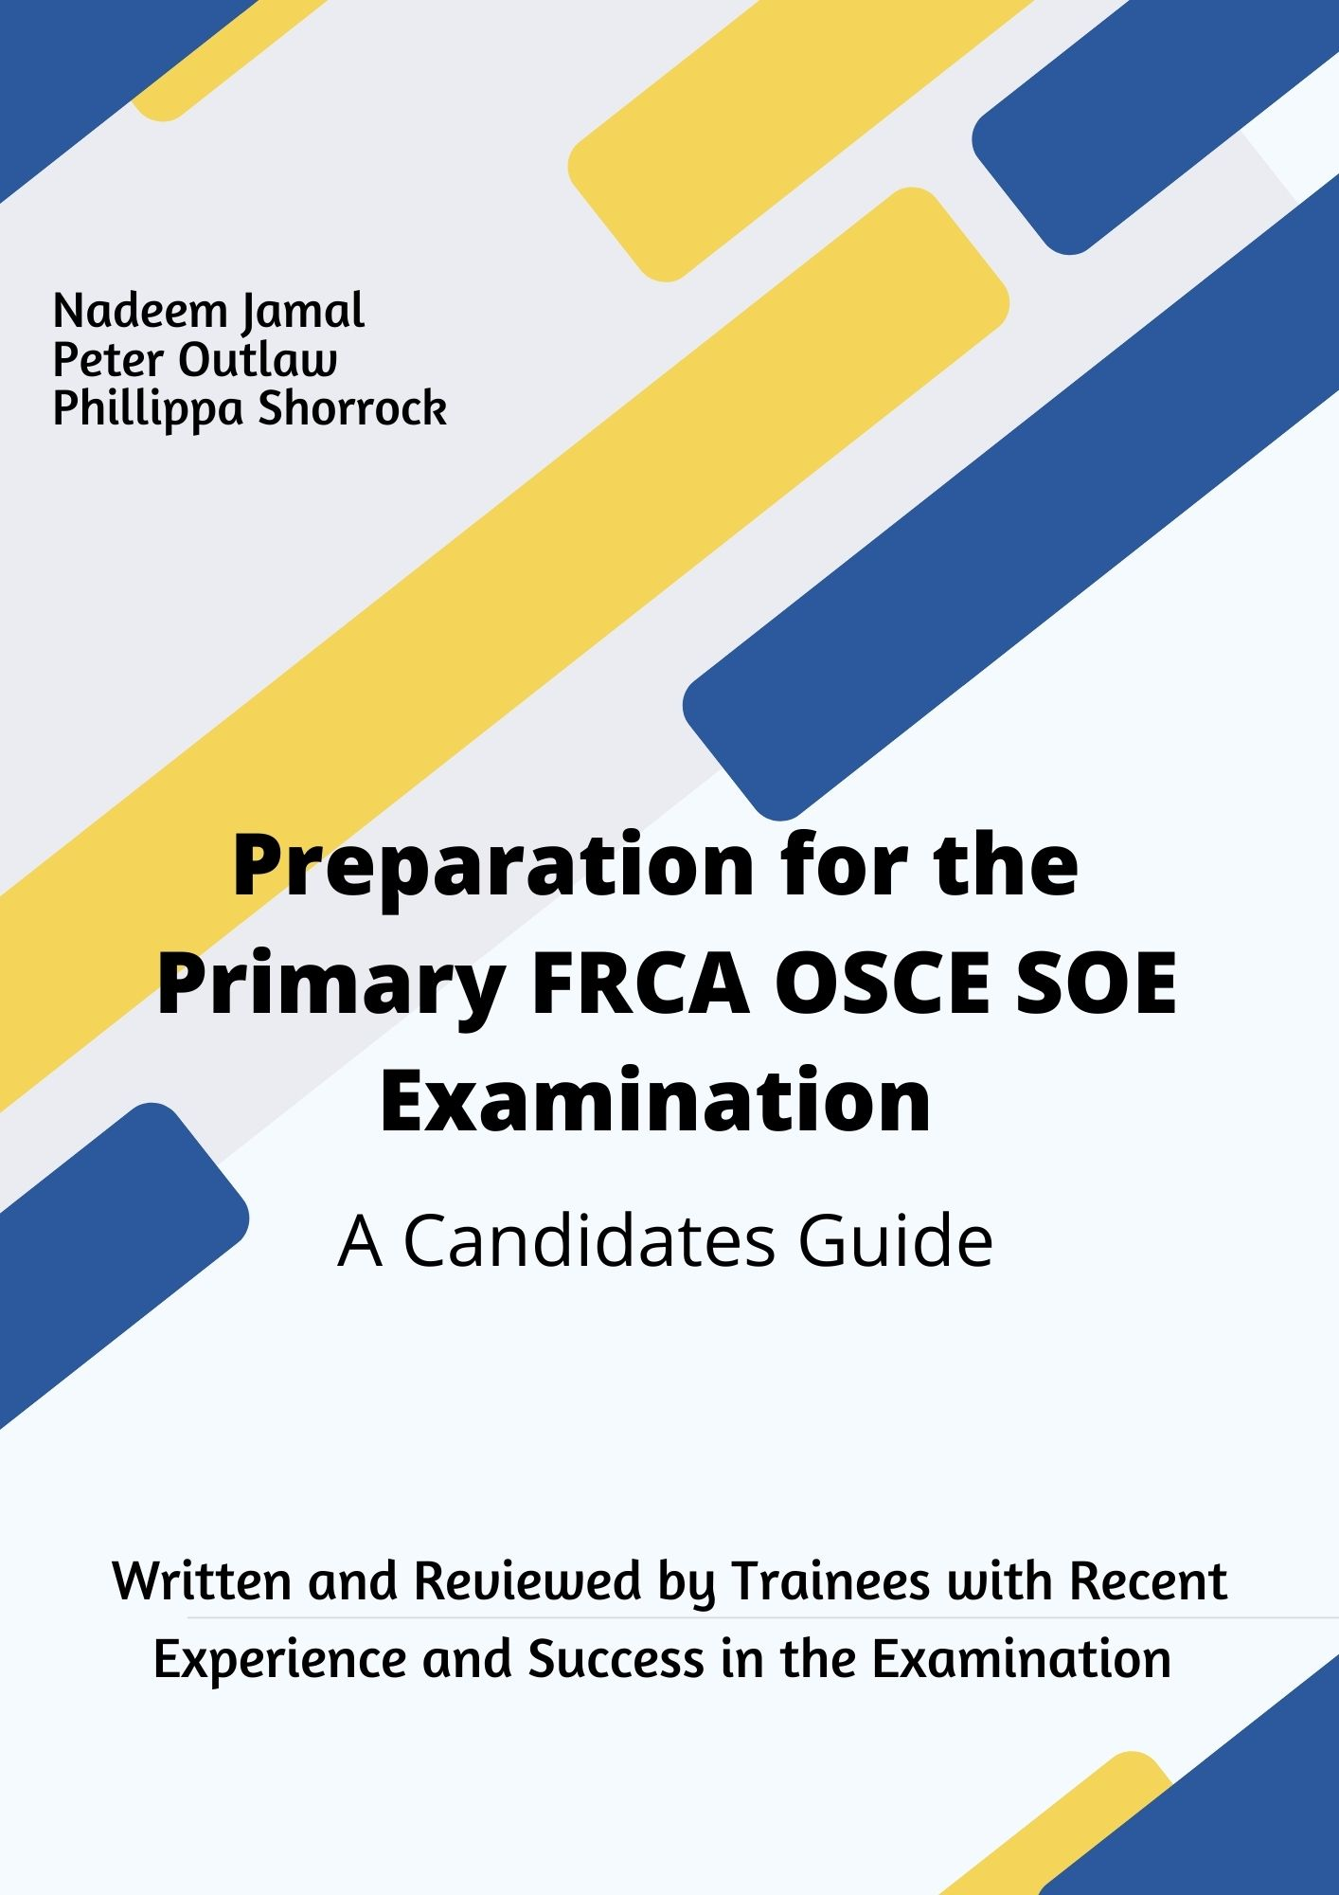
What do I need to think about before sitting the exam?

The best time to sit the Primary FRCA OSCE/SOE examination is when you feel ‘ready’ but how do you know when this is the case? The following information, aimed to be an informal aid, we hope will to assist you in your preparation for the exam and will help to kick start your revision. It accompanies the Primary FRCA OSCE/SOE Examination preparation course. We really hope you find it helpful.

General Format of the Examination
OSCE: one long 2.5 hours session comprised of 16 stations
SOE: 2 separate 30 minute sessions divided over 4 topics (physiology & pharmacology, physics & clinical

The Exam Day Itself
The College is returning to face-to-face delivery for the SOE and OSCE components of the FRCA exams from April 2022. The Primary MCQ component will remain online with remote proctoring.
Try to ensure your accommodation does not rely on public transport to get you to the Royal College building. There are various hotels nearby which are commonly used by trainees (and examiners!). Ask those who have recently sat the exam for advice on which hotel to use.
This is a professional postgraduate examination therefore erring on the smarter side such as an ironed shirt and smart trousers/skirt/dress is likely to be the most appropriate. First impressions are everything.
You are allowed to take a water bottle with you (highly recommended) to each station but no other equipment will be necessary to bring.
At the start of each station, you will be asked for your ID, the examiner will check you are the right candidate and they will then invite you to get on with the station/begin with their questioning.
If you encounter a bad station, whatever the reason, forget it and move on. This is a skill and should be practiced by doing consecutive stations with other trainees/consultants.
The examiners want to pass you (even though they may have an excellent poker face).
- For the SOE, structuring your answers in a way that makes it easy for the examiner to mark your performance will put them and subsequently yourself at ease.
- In the OSCE, it’s more rapid fire rounds where short snappy answers are important to get you to finish the station on time.
Finally, think of the exam as a chance to prove your knowledge to the examiners. You have already done the hard work of passing the MCQ and preparing for this immensely difficult exam. Well done on getting this far!

OSCE Set Up
The most important advice we can give is…DO NOT UNDERESTIMATE THE OSCE
Each station will be in a cubicle with an examiner, plus sometimes an extra observer and a simulated patient. The Examiner will be marking on an iPad as you go along.
Then when you finish a station, you move yourself to the next one.
Remember this is quick fire rounds, so be short and snappy with your answers. Finishing the station is key!
Each circuit will comprise of 16 x 5-minute stations including rest stations.
Before each station, you will read the guidance displayed outside of the cubicle.
You have one minute to read this guidance after which a bell will sound and you will enter the station.
In the station, an examiner may ask questions on a subject or you may be required to interact with a patient, played by an actor.
A bell will sound at the end of the 5 minutes and you will move to the next station.
If you feel you have had a bad station this does not mean a) that this is the case as candidates are terrible at judging whether performance in a station is good or bad or b) that you have failed the OSCE as there are no killer questions.
The trick as they say is to keep breathing. The OSCE is a long slog and you need to be able to start each station with fresh eyes and put a perceived bad station behind you.
Marking
- 16 live stations marked out of 20 is 320 marks total
- There are marks given for technique and structure in many questions as well as for eliciting specific information.
- You generally need about 13/14 on average to pass although each station may have a slightly different pass mark (Angoff referencing method).
- The examiner is required to ask the question as written in the OSCE. They are unable to rephrase or explain anything.
- In the OSCE you are unable to go back to earlier questions in the station after you have moved on.

OSCE Stations topics
Some may be repeated to total 16 stations (from RCOA website)
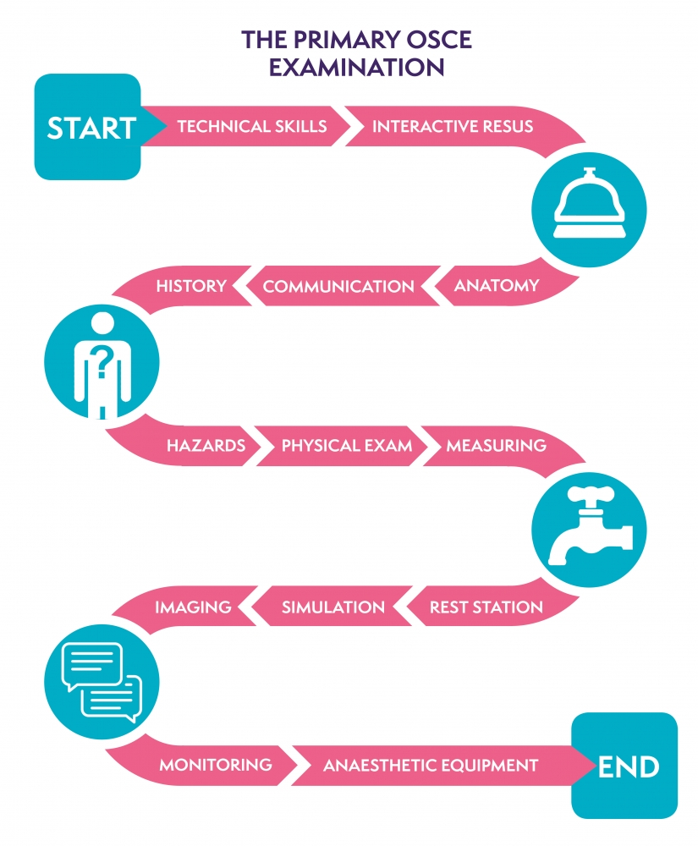
SOE Set Up
Similar to the OSCE, you will be in a cubicle with 2 examiners and sometimes an invigilator. The examiner is in charge of timing for each question, so don’t worry about this, they will move you on.
There are 2 x 30 minute sessions.
There are 4 sections in total (2 in each 30 minutes) in this order:
- 30 minutes
  - 3 questions in pharmacology
  - 3 questions in physiology and biochemistry
- 30 minutes
  - A clinical scenario (including a critical incident)
  - 3 questions in physics, clinical measurement, equipment and safety.
Most people know the 4 main topics but remember that physics also includes equipment and safety. Make sure you don’t leave this topic out of your revision! There are plenty of equipment textbooks available for the physics-naïve amongst us.
Some of the questions involve either drawing a table or diagram or labelling a picture. Practice these in the run up to the exam. You need to be able to draw quickly and draw and talk at the same time so you have every opportunity to gain marks.
Marking
- There are three 5 minute questions per section
- Each question is marked as either
  - 0 Fail
  - 1 Borderline
  - 2 Pass
- The two examiners mark separately with a total of 24 marks per examiner
- One examiner will ask the first set of questions and the other will be making notes on an iPad. They will then swap over for the 2nd set of questions. Both examiners mark all parts on an iPad.
- So you can achieve a total of 48 marks and you need to get 37 to pass
- Therefore, you can fail a question completely but still make up for it elsewhere.

Revision options
There is nothing better than practicing with other trainees. You may have partners, medic or otherwise, who are happy to ask you questions but unless they are an anaesthetist too they will have often never come across a lot of what we were revising. There is huge benefit from revising with other anaesthetists and listening to someone else answering the questions even if it is embarrassing at the start.
Even though the examination has returned to face to face there is still value in practicing in the virtual format as it is often easier to organize in our time pressured lives. There are multiple online formats for video chat to utilize as well such as Zoom, Teams and Google Hangouts.
After the most recent Primary FRCA OSCE/SOE Examination Preparation Courses a number of trainees have made their own revision Whatsapp group which many found useful.
Remember also that the North West School of Anaesthesia has a virtual viva club that you can sign up to for more practice.
Most departments will have consultants and post primary trainees who are keen to provide practice. Everyone is busy and time is precious. It is on you to provides dates and times you are available to practice with consultants and get fixed dates in diaries and remind people that they have made a commitment to practice so you can try to avoid last minute cancellations especially as the exam gets closer.
Beware of exam practice during theatre lists as this can often be distracting and unproductive.
Organising an in-house revision practice program within your department for yourself and your colleagues is an excellent way to illustrate a number of your Generic Professional Competencies as well as providing you with the maximum chances to be successful.
The people you practice with may not be examiners or have experience of the exam so you may need to provide questioning material and it is vital that you time yourself to give you the best feel for how it will be. Feedback on structure and format is essential. You can go away and real up on the facts later.
Candidates often poorly allocate time to, in addition to clinical measurement equipment and safety and do not forget time for anatomy.

What Should I Use to Revise?
Online Resources:
- E-learning for health website
- Dr Podcast (Also has Dr Podcast Scrips if you Prefer)
- Physics, pharmacology and physiology guides from RCOA - on E-learning for health
- RCOA youtube channel has some excellent videos on what is a fail, borderline or pass answer

Books
- RCOA guide to the Primary FRCA - best book for practice
- Quick reference handbook from AAGBI
- Masterpass - 2 books (watch out for mistakes and little cardiac physiology)
- Equipment in Anaesthesia and Critical Care by Aston, Rivers and Harmadasa
- Quick draw anatomy for anesthetics by Joanna Fox
- Drugs in Anesthesia and Intensive Care by Scarth
- Physics, Pharmacology and Physiology for Anaesthetists by Cross and Plunkett is succinct and has good diagrams
- Pharmacology for Anaesthesia and Intensive Care by Peck and Hill

Final Tips

- DON’T UNDERESTIMATE THE OSCE EXAMINATION

- Don’t tell them you don’t know something instead tell them what you do know

- Don’t forget time to revise anatomy

- The SOE is more about presentation and structure; classify or die

- If you are giving a list and can only remember 3 things rather than 5, instead of silence whilst trying to remember just move on

- Try to not let a bad station haunt you (which of course is easier said than done)

- You don’t need loads of new knowledge you passed the MCQ it’s now about how you present it and that you can show you understand it

- Don't focus on physiology in a physics viva – it’s not where the marks are

- Work on skills such as moving on from a bad station, body language, pace and structure when practicing

- Answer the question you are given don’t look for any hidden agenda

Lastly we just want you the best of luck as you prepare for your Primary FRCA OSCE/SOE examination and we look forward to seeing you on the Examination Preparation Course.

